Practical 5
Aim:- :- Apply array methods & object handling ; Creating a cart total calculator with discount logic.
Software/Tools Required:- VS Code, Web Browser
Practical Code:-
<!DOCTYPE html>
<html lang="en">
<head>
<meta charset="UTF-8">
<meta name="viewport" content="width=device-width, initial-scale=1.0">
<title>Smart Shopping Cart</title>
<title>Sanvi Wadhankar 24070521191</title>
<!-- <h1>Sanvi Wadhankar 24070521191</h1> -->

<link href="https://fonts.googleapis.com/css2?family=Poppins:wght@300;400;500;600;700&display=swap" rel="stylesheet">

<style>
*{
margin:0;
padding:0;
box-sizing:border-box;
font-family:'Poppins',sans-serif;
}

body{
min-height:100vh;
background:linear-gradient(135deg,#667eea,#764ba2);
display:flex;
justify-content:center;
align-items:center;
padding:20px;
}

.container{
width:850px;
max-width:100%;
background:rgba(255,255,255,0.15);
backdrop-filter:blur(15px);
border:1px solid rgba(255,255,255,0.2);
border-radius:25px;
padding:30px;
box-shadow:0 15px 35px rgba(0,0,0,0.2);
}

.title{
text-align:center;
color:white;
margin-bottom:10px;
font-size:2.2rem;
}

.subtitle{
text-align:center;
color:#eee;
margin-bottom:25px;
}

.cart-counter{
text-align:center;
color:white;
margin-bottom:20px;
font-weight:600;
}

.form-grid{
display:grid;
grid-template-columns:repeat(auto-fit,minmax(220px,1fr));
gap:15px;
}

.input-box{
position:relative;
}

.input-box input{
width:100%;
padding:15px;
border:none;
border-radius:12px;
outline:none;
background:white;
font-size:15px;
}

.input-box label{
position:absolute;
top:-10px;
left:15px;
background:white;
padding:2px 8px;
border-radius:8px;
font-size:12px;
color:#555;
}

.btn-group{
display:flex;
gap:15px;
margin-top:20px;
}

button{
flex:1;
border:none;
padding:14px;
border-radius:12px;
font-size:16px;
font-weight:600;
cursor:pointer;
transition:0.3s;
}

.add-btn{
background:#00c853;
color:white;
}

.bill-btn{
background:#2962ff;
color:white;
}

button:hover{
transform:translateY(-3px);
box-shadow:0 8px 20px rgba(0,0,0,0.2);
}

.discount-bar{
margin-top:20px;
}

.progress{
width:100%;
height:18px;
background:white;
border-radius:20px;
overflow:hidden;
}

.progress-fill{
height:100%;
width:0%;
background:linear-gradient(to right,#00c853,#64dd17);
transition:0.5s;
}

.discount-text{
color:white;
margin-top:8px;
text-align:center;
font-size:14px;
}

.cart-section{
margin-top:25px;
}

.cart-item{
background:white;
border-radius:15px;
padding:15px;
margin-bottom:12px;
display:flex;
justify-content:space-between;
align-items:center;
transition:0.3s;
}

.cart-item:hover{
transform:scale(1.02);
}

.product-name{
font-weight:600;
color:#333;
}

.price-tag{
background:#e8f5e9;
color:#2e7d32;
padding:5px 12px;
border-radius:20px;
font-size:14px;
font-weight:600;
}

.delete-btn{
background:#ff1744;
color:white;
border:none;
padding:6px 10px;
border-radius:8px;
cursor:pointer;
}

.summary{
background:white;
border-radius:18px;
padding:20px;
margin-top:20px;
}

.summary h3{
margin-bottom:10px;
}

.amount{
display:flex;
justify-content:space-between;
margin:10px 0;
}

.discount{
color:#d32f2f;
font-weight:600;
}

.final{
color:#00c853;
font-size:22px;
font-weight:700;
}

.badge{
display:inline-block;
background:#ff1744;
color:white;
padding:5px 12px;
border-radius:20px;
font-size:12px;
margin-bottom:10px;
}

.toast{
position:fixed;
top:20px;
right:20px;
background:#00c853;
color:white;
padding:12px 18px;
border-radius:10px;
opacity:0;
transition:0.4s;
z-index:1000;
}

.toast.show{
opacity:1;
}

.empty{
text-align:center;
color:white;
font-size:18px;
margin-top:20px;
}
</style>
</head>

<body>

<div class="toast" id="toast"></div>

<div class="container">

<h1 class="title">🛒 Smart Shopping Cart</h1>
<h1 class="title">Sanvi Wadhankar 24070521191</h1>
<p class="subtitle">Array • Object • Array of Objects • Reduce Method</p>

<div class="cart-counter">
Items in Cart: <span id="cartCount">0</span>
</div>

<div class="form-grid">

<div class="input-box">
<label>Product Name</label>
<input type="text" id="name">
</div>

<div class="input-box">
<label>Price (₹)</label>
<input type="number" id="price">
</div>

<div class="input-box">
<label>Quantity</label>
<input type="number" id="quantity">
</div>

</div>

<div class="btn-group">
<button class="add-btn" onclick="addToCart()">
➕ Add Product
</button>

<button class="bill-btn" onclick="calculateBill()">
💳 Generate Bill
</button>
</div>

<div class="discount-bar">
<div class="progress">
<div class="progress-fill" id="progressFill"></div>
</div>

<div class="discount-text" id="discountLevel">
Current Discount: 0%
</div>
</div>

<div class="cart-section" id="output">
<div class="empty">No products added yet.</div>
</div>

</div>

<script>

// Array of Objects
let cart = [];

function showToast(message){

let toast = document.getElementById("toast");
toast.innerText = message;

toast.classList.add("show");

setTimeout(()=>{
toast.classList.remove("show");
},2000);
}

function addToCart(){

let name = document.getElementById("name").value.trim();
let price = Number(document.getElementById("price").value);
let quantity = Number(document.getElementById("quantity").value);

if(name === "" || price <= 0 || quantity <= 0){
showToast("Enter valid product details");
return;
}

// Object
let product = {
name:name,
price:price,
quantity:quantity
};

cart.push(product);

document.getElementById("name").value="";
document.getElementById("price").value="";
document.getElementById("quantity").value="";

showToast("Product Added Successfully");

displayCart();
}

function deleteItem(index){

cart.splice(index,1);

displayCart();

showToast("Product Removed");
}

function displayCart(){

document.getElementById("cartCount").innerText = cart.length;

if(cart.length===0){
document.getElementById("output").innerHTML=
`<div class="empty">No products added yet.</div>`;
return;
}

let output="";

cart.forEach((item,index)=>{

output+=`
<div class="cart-item">

<div>
<div class="product-name">${item.name}</div>
<small>
₹${item.price} × ${item.quantity}
</small>
</div>

<div style="display:flex;gap:10px;align-items:center;">

<div class="price-tag">
₹${item.price * item.quantity}
</div>

<button class="delete-btn"
onclick="deleteItem(${index})">
🗑
</button>

</div>

</div>
`;
});

document.getElementById("output").innerHTML = output;
}

function calculateBill(){

if(cart.length===0){
showToast("Cart is Empty");
return;
}

// Reduce Method
let total = cart.reduce((sum,item)=>{
return sum + (item.price * item.quantity);
},0);

let discountPercent = 0;
if(total>9000){
discountPercent = 30;
}
else if(total >= 5000){
discountPercent = 20;
}
else if(total >= 3000){
discountPercent = 15;
}
else if(total >= 1000){
discountPercent = 10;
}
else{
discountPercent = 5;
}

let discount = total * (discountPercent/100);

let finalAmount = total - discount;

document.getElementById("progressFill").style.width =
discountPercent * 5 + "%";

document.getElementById("discountLevel").innerText =
`Current Discount: ${discountPercent}%`;

let billHTML = "";

cart.forEach((item,index)=>{

billHTML+=`
<div class="cart-item">

<div>
<div class="product-name">${item.name}</div>
<small>
₹${item.price} × ${item.quantity}
</small>
</div>

<div style="display:flex;gap:10px;align-items:center;">

<div class="price-tag">
₹${item.price * item.quantity}
</div>

<button class="delete-btn"
onclick="deleteItem(${index})">
🗑
</button>

</div>

</div>
`;
});

billHTML += `

<div class="summary">

<span class="badge">
${discountPercent}% Discount Applied
</span>

<h3>Bill Summary</h3>

<div class="amount">
<span>Total Amount</span>
<span>₹${total.toFixed(2)}</span>
</div>

<div class="amount discount">
<span>Discount</span>
<span>- ₹${discount.toFixed(2)}</span>
</div>

<hr>

<div class="amount final">
<span>Final Amount</span>
<span>₹${finalAmount.toFixed(2)}</span>
</div>

</div>
`;

document.getElementById("output").innerHTML = billHTML;

showToast("Bill Generated Successfully");
}

</script>

</body>
</html>
Output:-
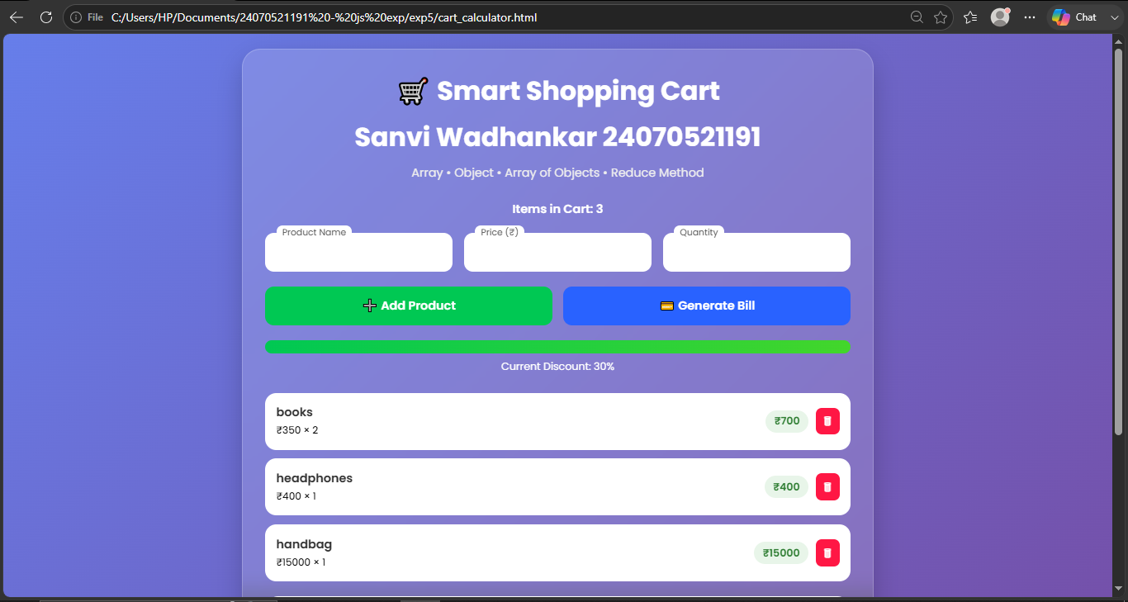
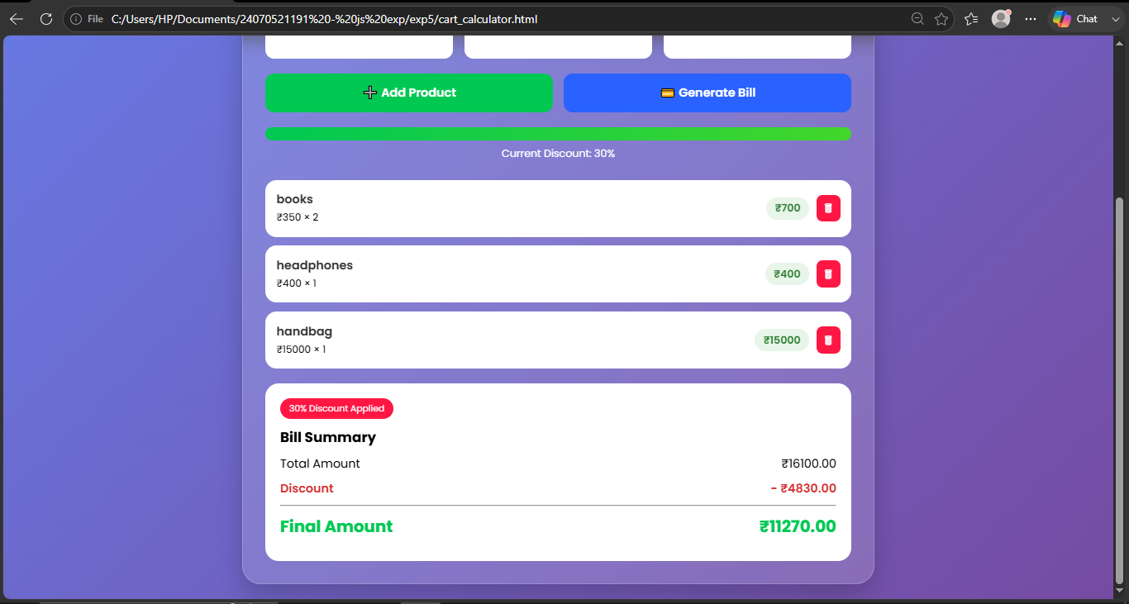

Case-Study 05
Aim:- :- To study the functioning of Arrays and Loops in JavaScript
- Create and manipulate arrays using `push()`, `pop()`, `shift()`, `unshift()`, `splice()`, and `slice()`.
- Use array methods `map()`, `filter()`, `reduce()`, and `forEach()`.
- Case Study: Create an array of numbers and find the maximum and minimum values.
Software/Tools Required:- VS Code , Web Browser
Expermient Code:-
Index.html:-
<!DOCTYPE html>
<html lang="en">
<head>
<meta charset="UTF-8">
<meta name="viewport" content="width=device-width, initial-scale=1.0">
<title>Cricket Player Statistics</title>
<link rel="stylesheet" href="style.css">
</head>

<body>
<div class="container">
<header>
<h1>🏏 Cricket Player Statistics</h1>
<p>Sanvi Wadhankar 24070521191</p>
<p>Explore Player Performance Using JavaScript Arrays</p>
</header>
<!-- Player List -->
<section class="card">
<h2>🏆 Player Scores</h2>
<div id="playerList" class="players"></div>
</section>
<!-- Array Operations -->
<section class="card">

<h2>🔧 Array Operations</h2>

<div class="buttons">

<button onclick="addPlayer()">Push Player</button>
<button onclick="removeLastPlayer()">Pop Player</button>
<button onclick="removeFirstPlayer()">Shift Player</button>
<button onclick="addFirstPlayer()">Unshift Player</button>
<button onclick="replacePlayer()">Splice Player</button>
<button onclick="showSlice()">Slice Players</button>
<button onclick="resetPlayers()">Reset</button>

</div>

<div id="operationResult" class="result">
Select an operation
</div>

</section>

<!-- Array Methods -->
<section class="card">

<h2>📊 Array Methods</h2>

<div class="buttons">

<button onclick="useMap()">map()</button>

<button onclick="useFilter()">filter()</button>

<button onclick="useReduce()">reduce()</button>
<button onclick="useForEach()">forEach()</button>

</div>

<div id="methodResult" class="result">
Select an array method
</div>

</section>

<!-- Statistics -->
<section class="card">

<h2>📈 Team Statistics</h2>

<button onclick="calculateStatistics()">
Calculate Statistics
</button>

<div class="stats">

<div>
<h3>Total Runs</h3>
<p id="totalRuns">-</p>
</div>

<div>
<h3>Highest Score</h3>
<p id="highestScore">-</p>
</div>

<div>
<h3>Lowest Score</h3>
<p id="lowestScore">-</p>
</div>

<div>
<h3>Players Above 50</h3>
<p id="above50">-</p>
</div>

</div>
</section>
</div>
<script src="script.js"></script>
</body>
</html>
Script.js:-
// Player array
const originalPlayers = [
{ name: "Virat", runs: 85 },
{ name: "Rohit", runs: 72 },
{ name: "Gill", runs: 45 },
{ name: "Pant", runs: 63 },
{ name: "Hardik", runs: 91 }
];
let players = [...originalPlayers];
// Display players
function displayPlayers() {

const playerList = document.getElementById("playerList");

playerList.innerHTML = "";

players.forEach((player, index) => {

playerList.innerHTML += `
<div class="player">

<div class="icon">🏏</div>

<h3>${player.name}</h3>

<p class="runs">${player.runs}</p>

<p class="label">Runs</p>

</div>
`;
});
}
displayPlayers();
// PUSH
function addPlayer() {

players.push({
name: "Rahul",
runs: 55
});

displayPlayers();

showOperation("push() → Rahul added to the team");
}
// POP
function removeLastPlayer() {

const removed = players.pop();

displayPlayers();

showOperation(
`pop() → ${removed.name} removed`
);
}
// SHIFT
function removeFirstPlayer() {

const removed = players.shift();

displayPlayers();

showOperation(
`shift() → ${removed.name} removed`
);
}
// UNSHIFT
function addFirstPlayer() {

players.unshift({
name: "Dhoni",
runs: 78
});

displayPlayers();

showOperation(
"unshift() → Dhoni added at beginning"
);
}
// SPLICE
function replacePlayer() {

if (players.length > 1) {

players.splice(1, 1, {
name: "Jadeja",
runs: 68
});

}

displayPlayers();

showOperation(
"splice() → Second player replaced by Jadeja"
);
}
// SLICE
function showSlice() {

const result = players.slice(0, 3);

showOperation(
`slice(0, 3) → ${result
.map(player => player.name)
.join(", ")}`
);
}
// MAP
function useMap() {

const result = players.map(
player => player.runs + 10
);

document.getElementById("methodResult").innerHTML =
`map() → Added 10 bonus runs:<br>
[ ${result.join(", ")} ]`;
}
// FILTER
function useFilter() {

const result = players.filter(
player => player.runs > 50
);

document.getElementById("methodResult").innerHTML =
`filter() → Players scoring above 50:<br>
${result.map(player => player.name).join(", ")}`;
}
// REDUCE
function useReduce() {

const total = players.reduce(
(sum, player) => sum + player.runs,
0
);

document.getElementById("methodResult").innerHTML =
`reduce() → Total Team Runs = ${total}`;
}
// FOREACH
function useForEach() {

let result = "";

players.forEach(player => {
result += `${player.name}: ${player.runs} runs<br>`;
});

document.getElementById("methodResult").innerHTML =
`forEach() →<br>${result}`;
}
// Calculate statistics
function calculateStatistics() {

// Total runs using reduce()
const totalRuns = players.reduce(
(sum, player) => sum + player.runs,
0
);

// Maximum and minimum
const highest = Math.max(
...players.map(player => player.runs)
);

const lowest = Math.min(
...players.map(player => player.runs)
);

// Players above 50 using filter()
const above50 = players.filter(
player => player.runs > 50
).length;

document.getElementById("totalRuns").textContent =
totalRuns;

document.getElementById("highestScore").textContent =
highest;

document.getElementById("lowestScore").textContent =
lowest;

document.getElementById("above50").textContent =
above50;
}
// Show operation
function showOperation(message) {

document.getElementById("operationResult").textContent =
message;
}
// Reset
function resetPlayers() {

players = [...originalPlayers];

displayPlayers();

document.getElementById("operationResult").textContent =
"Array reset successfully.";

document.getElementById("methodResult").textContent =
"Select an array method";

document.getElementById("totalRuns").textContent = "-";
document.getElementById("highestScore").textContent = "-";
document.getElementById("lowestScore").textContent = "-";
document.getElementById("above50").textContent = "-";
}
Style.css:-
* {
box-sizing: border-box;
margin: 0;
padding: 0;
font-family: Arial, sans-serif;
}
body {
background: #eef2f7;
color: #222;
padding: 30px;
}
.container {
max-width: 1000px;
margin: auto;
}
/* Header */
header {
background: #166534;
color: white;
padding: 30px;
text-align: center;
border-radius: 15px;
margin-bottom: 25px;
}
header h1 {
font-size: 34px;
margin-bottom: 8px;
}
header p {
font-size: 16px;
}
/* Cards */
.card {
background: white;
padding: 25px;
margin-bottom: 20px;
border-radius: 15px;
box-shadow: 0 4px 12px rgba(0, 0, 0, 0.08);
}
.card h2 {
margin-bottom: 20px;
color: #166534;
}
/* Players */
.players {
display: grid;
grid-template-columns: repeat(3, 1fr);
gap: 15px;
}
.player {
background: #f0fdf4;
border: 1px solid #bbf7d0;
padding: 18px;
border-radius: 10px;
text-align: center;
}
.player .icon {
font-size: 35px;
}
.player h3 {
margin: 8px 0;
}
.runs {
font-size: 24px;
font-weight: bold;
color: #166534;
}
.label {
color: #666;
font-size: 13px;
}
/* Buttons */
.buttons {
display: flex;
flex-wrap: wrap;
gap: 8px;
}
button {
padding: 10px 15px;
border: none;
border-radius: 7px;
background: #166534;
color: white;
cursor: pointer;
}
button:hover {
background: #14532d;
}
/* Result */
.result {
margin-top: 20px;
padding: 15px;
background: #f8fafc;
border-left: 4px solid #166534;
min-height: 50px;
line-height: 1.6;
}
/* Statistics */
.stats {
display: grid;
grid-template-columns: repeat(4, 1fr);
gap: 15px;
margin-top: 20px;
}
.stats div {
background: #f0fdf4;
padding: 20px;
text-align: center;
border-radius: 10px;
}
.stats h3 {
font-size: 15px;
margin-bottom: 10px;
}
.stats p {
font-size: 25px;
font-weight: bold;
color: #166534;
}
/* Responsive */
@media (max-width: 700px) {

.players {
grid-template-columns: 1fr 1fr;
}

.stats {
grid-template-columns: 1fr 1fr;
}
}
@media (max-width: 450px) {

.players {
grid-template-columns: 1fr;
}

.stats {
grid-template-columns: 1fr;
}
}
Output:-
